**SUHASITA RANI(231701013)EXPERIMENT-3**

**HOBBY APP**

**AIM**

TO DESIGN A HOBBY APP

**PROCEDURE**

* Select the number of wireframes according to

the need

* Create a login page in the very first wireframe

* Decide the number of hobbies for eg(4)

* Select the categories

(singing,dancing,cooking,reading)

*Have the description for every category in

separate wireframes

*Finally have a end page which boosts to make

hobby as career

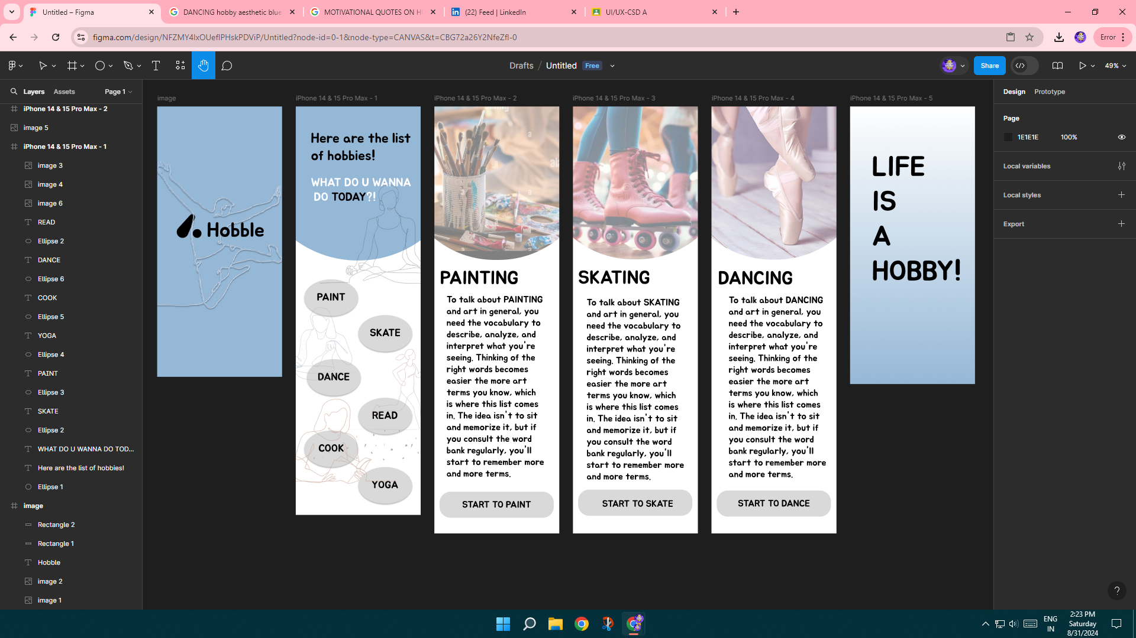

**RESULT**

A Hobby app is designed